**Project Design Phase II _ Architecture Technology**

**Project Title**: Smart Solution for Railways **Team ID**: PNT2022TMID42986

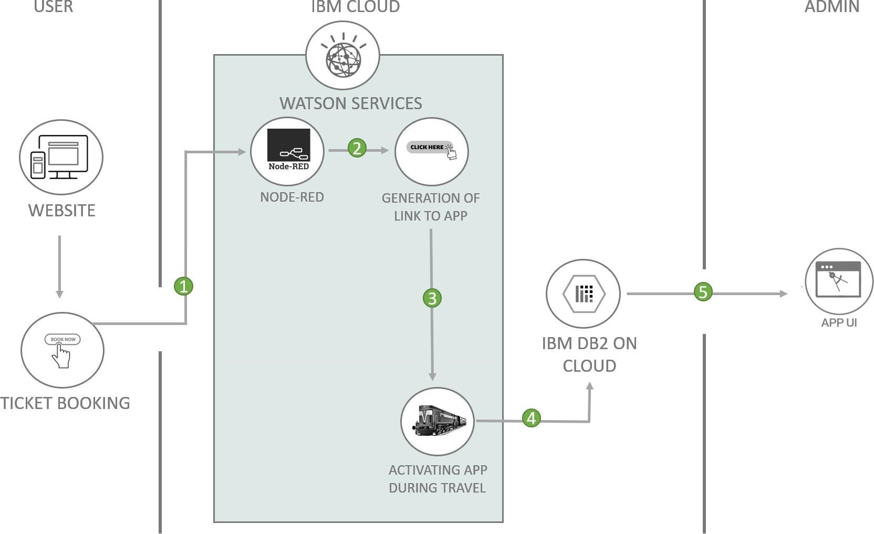

**Technical Architecture:**

The Deliverable shall include the architectural diagram as below and the information as per the table1 & table 2

**Components & Technologies:**

|  |  |  |  |
| --- | --- | --- | --- |
| **S.No** | **Component** | **Description** | **Technology** |
| 1. | User Interface | How user interacts with application e.g Web UI, Mobile App, Chatbot etc. | HTML, CSS |
| 2. | Application Logic | Logic for a process in the application | Python |
| 3. | Database | Data Type, Configurations etc. | SQL |
| 4. | Cloud Database | Database Service on Cloud | IBM DB2, IBM Cloud ant etc. |
| 5. | File Storage | File storage requirements | IBM Block Storage or Other Storage Service or Local File system |

**Application Characteristics:**

|  |  |  |  |
| --- | --- | --- | --- |
| **S.No** | **Characteristics** | **Description** | **Technology** |
| 1. | Open-Source Frameworks | List the open-source frameworks used | Technology of Opensource framework |
| 2. | Security Implementations | List all the security / access controls implemented, use of firewalls etc. | e.g. SHA-256, Encryptions, IAM Controls, OWASP etc. |
| 3. | Scalable Architecture | Justify the scalability of architecture (3 – tier, Micro-services) | Technology used |
| 4. | Availability | Justify the availability of application (e.g. use of load balancers, distributed servers etc.) | Technology used |
| 5. | Performance | Design consideration for the performance of the application (number of requests per sec, use of Cache, use of CDN’s) etc. | Technology used |